**EXPLANATION OF HOTEL INFORMATION CHATBOT**

This Flask-based Hotel Information Chatbot provides a user-friendly web interface for guests to inquire about hotel services, room types, amenities, policies, and more.

* **Key Features**:
  + **Multiple room categories** (Standard, Deluxe, Suite, Family)
  + **Detailed amenities** (Pool, Spa, Business Center)
  + **Policies** (Cancellation, Pet rules)
  + **Location & Transport** (Airport distance, subway access)
  + **Special Offers** (Discounts, packages)

**How It Works**:

1. **Checks keywords** (e.g., "room", "price", "location").
2. **Fetches relevant data** from HOTEL_INFO.
3. **Formats responses** in a user-friendly way

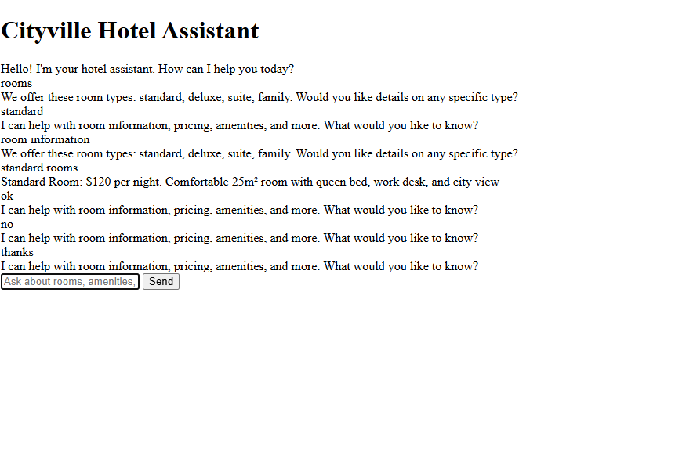

**Conclusion :**

This chatbot provides a simple yet powerful way for hotel guests to get information instantly.